Species | Size | Physical Description | Diet | Preferred Habitat | Harvest Info | Special Considerations:
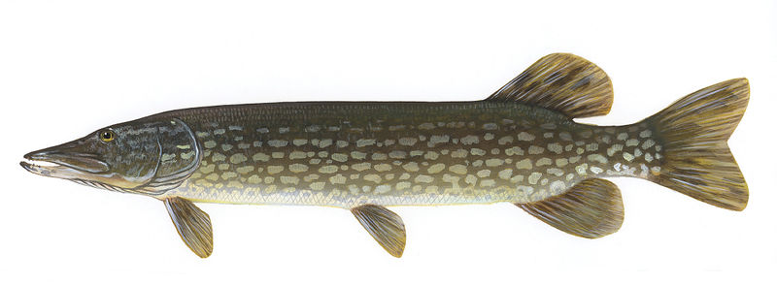  Northern Pike | - up to 22 kg  - up to 120 cm | - long rounded body  - very ”toothy”  - mottled green with gold flecks | - will eat insects, but are voracious predators and feed on other fish | - prefers shallow, weedy clear water in lakes and marshes, but can also be found in slow streams | - easily caught in both hard and open water situations. Fly fishing for pike is a challenge. Can be caught from shore as well as from a boat. Will take both lures and baits resembling any food source | - 3 over 63 cm, unless a designated trophy lake, then specific regulations apply
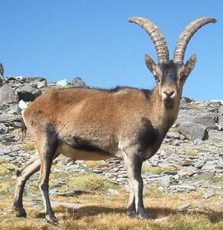  Spanish Ibex | - 80 – 100 kg  - horns to 1 m | - large curved horns with rings  - shaggy beard or throat mane  - hard edged, soft centered hooves | - survives on hardy mountain plants | - mountainous areas of Spain  - prefers mid to high altitudes | - hunting has become mainly a sport of the affluent in Spain. Tags are controlled by landowner with gov’t permissions | - hunting is done by foot, occasionally using dogs for tracking

Species | Size | Physical Description | Diet | Preferred Habitat | Harvest Info | Notes:

